Dyshawn Payne

10-28-22

CTEC 298

Anaconda and Jupyter Proof of Install

Homepage Anaconda

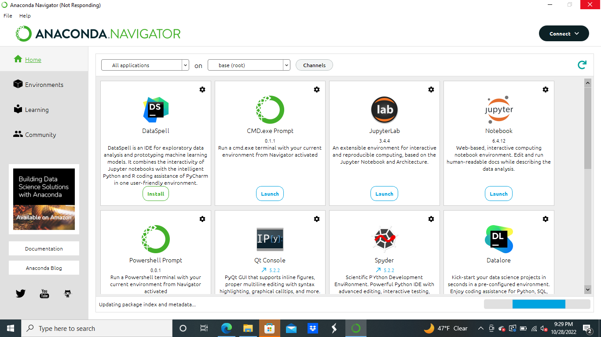

Homepage Jupyter

